msdn Content
Experience Visual Studio.NET

Introduction 3

Setup 4

Lab 1: Hello World 6

Lab 2: XML Comments 12

Lab 3: ASP vs. ASP.NET 23

Lab 4: Server Controls Walkthrough 28

Lab 5: Using the Visual Basic Upgrade Wizard 31

Lab 6: Browser-Based Application 37

Lab 7: Inheritance and Override 42

Reset Instructions 48

Additional Resources 48

Introduction

These hands-on labs will expose you to the programming features within Visual Studio.NET. You will be introduced to C#, ASP.NET and Visual Basic.NET in a variety of ways. You will look at, run, and debug code using the Visual Studio.NET Integrated Development Environment (IDE). You will take an application in Microsoft® Visual Basic® 6.0 and migrate it to Visual Basic.NET, and then extend it with additional Visual Basic.NET programming concepts. When you leave this hands-on lab, you will be able to identify the key new features of Visual Studio.NET and the programming elements within.

This lab manual has been updated to work with the released Visual Studio.NET Beta 2.

Resources:

MSDN events online: http://msdn.microsoft.com/training/seminars/quarterlyevent.asp

TechNet events online: http://www.microsoft.com/technet/events

MSDN web: http://msdn.microsoft.com

Visual Studio.NET online: http://msdn.microsoft.com/vstudio/nextgen

Setup

Here is what is expected on your machine in order for the lab to work.

Minimum Hardware Requirements
Processor | Pentium 3 650Mhz
Memory | 256mb
Disk Space | 6 GB

Software required before demo installation
Required Operating Systems | Windows 2000 Advanced Server
 | Microsoft Windows 2000 Service Pack 1
 | Windows 2000 Advanced Server
 | Microsoft Visual Studio 6.0 Enterprise Edition
 | Microsoft Visual Studio 6.0 SP5
 | Microsoft SQL Server 2000 Enterprise Edition
 | Microsoft Office XP Professional with FrontPage
 | Microsoft Visual Studio.NET Beta 2 Build 9160 (Enterprise Edition)

Demo Machine Setup

To set up the hardware
- Set up the hardware according to the manufacturer’s instructions. (Refer to the Minimum Hardware Requirements section in this document.)

Create a basic install of Windows 2000 Advanced Server
- Select to create or convert to a NTFS partition during setup.
- Reboot the PC once installation is completed

To configure FrontPage 2000 Server Extensions
- Open Control Panel.
- Click Add/Remove Windows Components.
- Double-click on Internet Information Services (IIS).
- Select FrontPage 2000 Server Extensions.
- Click OK.
- Click Next.
- Click Finish.
- Click Close.

Install Windows 2000 Advanced Server Service Pack 1

Install SQL Server 2000 Enterprise Edition
- Walk through the SQL setup accepting all defaults EXCEPT for the Authentication Mode page, which should be changed to Mixed Mode. Use a blank password for the sa login.

Install Visual Studio 6.0 Enterprise Edition
- Perform a default install, install everything except FoxPro, InterDev, and Visual Source Safe.

Install Visual Studio 6.0 SP5

Install Microsoft Office XP Professional with FrontPage
- Perform a complete install of Office XP

Install VS.NET Beta 2

Install .NET Framework SDK Samples and QuickStart Tutorials
- Navigate to Start | Programs | Microsoft .NET Framework SDK | Samples and QuickStart Tutorials.
- Follow the instructions and step through all installation steps as specified.

Install Lab files
- Install HOLT1-01 Experience Visual Studio.NET.MSI.
- Execute Setup.vbs.

Lab 1: Hello World

In this hands-on lab, you will create the Hello World application in C#. You will use the Microsoft Visual Studio.NET Integrated Development Environment (IDE) to create, compile, and run this lab.

Creating a New Project in the IDE
- Open the IDE by navigating to Start | Programs |
Microsoft Visual Studio.NET 7.0 | Microsoft Visual Studio.NET 7.0. The IDE Start page appears (Figure 1).

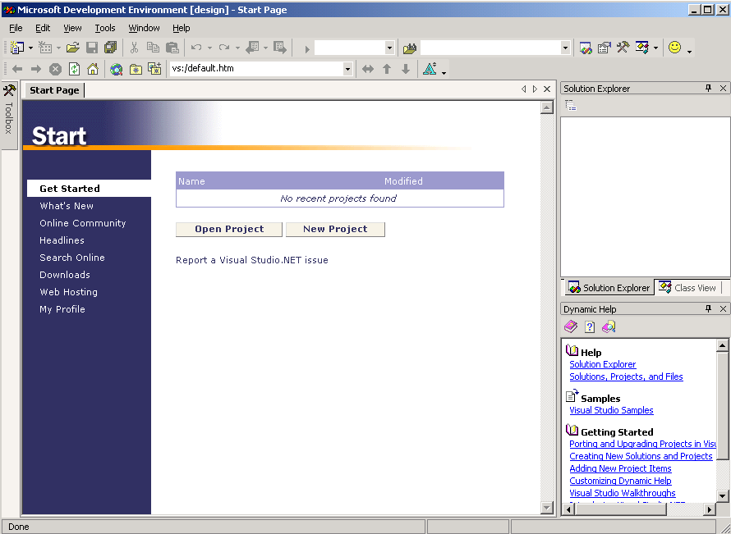

Figure 1 Start page in the Visual Studio.NET IDE

The Start page opens by default when you start the IDE. It provides links to the last four projects that you have worked on within the environment, and also provides additional resource links.

You can change all of the default settings by selecting Tools | Options and choosing your preferences.
- Select File | New | Project. The New Project window appears (Figure 2).

The default location is C:\Documents and Settings\Administrator\My Documents\Visual Studio Projects\.

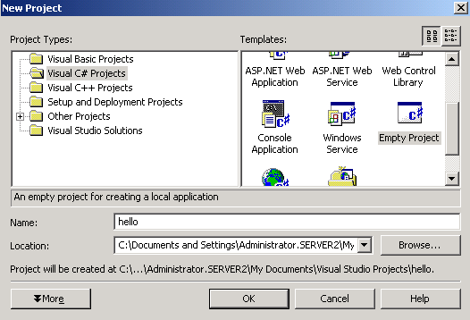

Figure 2 New Project window
- In the Project Types pane, click Visual C# Projects.
- In the Templates pane, click Empty Project.
- Type “hello” in the Name field, and then choose a location for your project.
- Click OK.

Creating the hello.cs Source File

The hello.cs file is the source file used in this lab. You will create the file within the hello project.
- Select File | Add New Item. The Add New Item window appears (Figure 3).
- In the Categories pane, click Local Project Items.
- In the Templates pane, click Code File.
- Type “hello.cs” in the name field.
- Click Open.

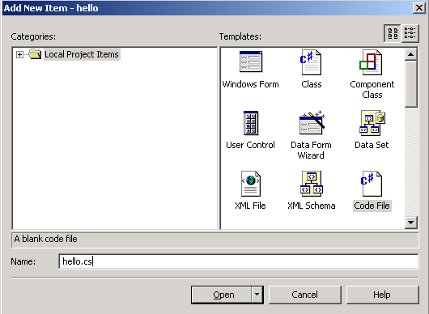

Figure 3 Add New Item window
- Type the following code into the page.
using System;
public class HelloWorld {
static void Main() {
Console.WriteLine("Hello World!");
}
}
- Select File | Save hello.cs, or click the save icon . The file is saved to your project folder.

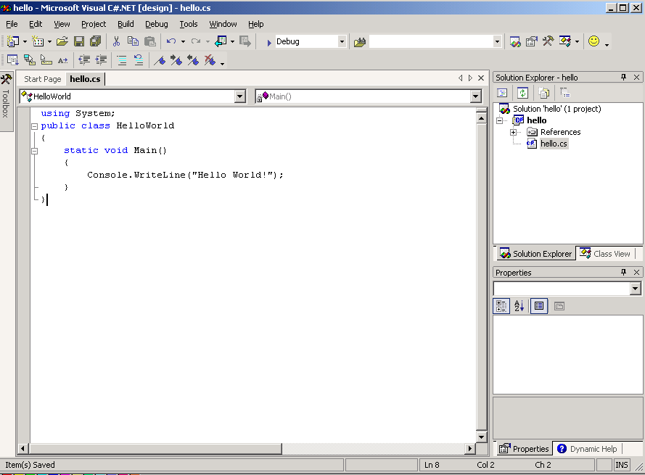

Figure 4 The hello.cs source file

In C# (unlike C or C++), there are no global methods. All methods belong to a class.

The .NET framework requires that all method names begin with a capital letter. So, a method named Main() would work in the .NET framework while a method named main() would not.

The “using System;” line tells the compiler that all classes and types from the System namespace are available to this program. The system namespace includes basic types, such as int and string.

The “public class HelloWorld” line declares a class named “HelloWorld”. This means that the “HelloWorld” class can be accessed by any other class.

The “static void Main()” line is the program’s entry point. The entry point is the point where the program, or executable file, starts. This line is required at the beginning of every executable file within a program.

The “Console.WriteLine(“Hello World!”);” line uses the WriteLine() method of the Console class within the system namespace. The parameter Hello World! is passed to Console.WriteLine(), and “Hello World!” is displayed on the screen when the program is executed.

Console.WriteLine() can be used instead of System.Console.WriteLine() because the System namespace is declared at the top of the file.

Building the Executable File

Build the executable file from within the IDE by selecting Build | Build or by clicking the build icon .

The IDE builds the executable file hello.exe and places it in the C:\Documents and Settings\Administrator\My Documents\Visual Studio Projects\hello\bin\Debug folder.

During the build, the Output window appears in the IDE (Figure 5). If any errors occur during the build, they will be reported in this window.

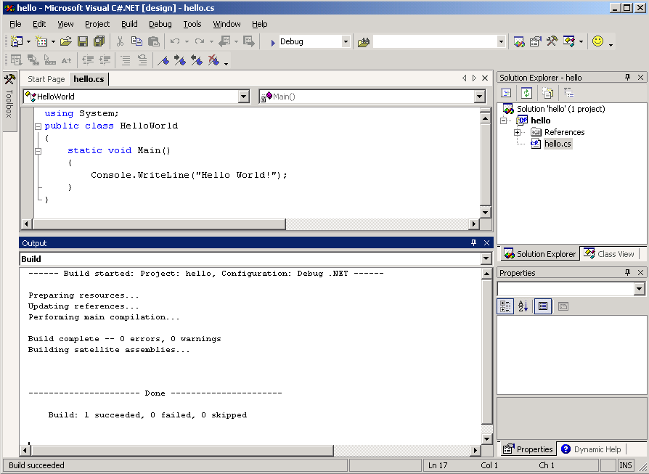

Figure 5 Output window within the IDE

Running the Program

You can now run the program from within the IDE.
- Select Debug | Start Without Debugging. Hello World! is printed to a Microsoft MS-DOS® window (Figure 6).

Because this program is a very small executable file that prints text to an MS-DOS screen, you will run it with debugging turned off. This allows you to see the results.

Keep in mind that the “Press any key to continue” line after “Hello World!” is not part of the program.

The first time an executable file is run in the .NET platform, it is compiled to native code. This may cause a delay in displaying the results. The executable file runs faster the next time it is executed.

No object (.obj) files are created as a result of invoking the C# compiler; output files are created directly. Consequently, the C# compiler does not need a linker.

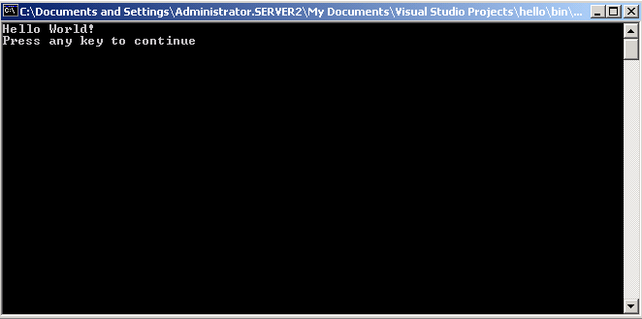

Figure 6 Hello World! program results
- Close the MS-DOS window.

Closing Out

Select File | Exit.

Lab 2: XML Comments

In this hands-on lab you will use the C# compiler to generate an Extensible Markup Language (XML) file from XML comments that have been inserted into a C# source file. You can use XML-related comment marks within the C# code to specify which comments should be output to the XML file.

The XML file can be used as documentation for your code. You can then add new comments or edit existing ones, thus keeping documentation together with the code it refers to. To create an updated record of documentation, you regenerate the XML file.

In this lab, you will:
- Use the Microsoft Visual Studio.NET Integrated Development Environment (IDE) to create and edit project files.
- Create an XML file (doc.xml).
- Open the project and source file within the IDE.
- Compile the sample using the MS-DOS command prompt.
- Apply an Extensible Stylesheet Language (XSL) template to the XML file.
- Open the final version of doc.xml

Creating a New Project in the IDE
- Navigate to Start | Programs | Microsoft Visual Studio.NET 7.0 | Microsoft Visual Studio.NET 7.0. The IDE Start page appears (Figure 1).

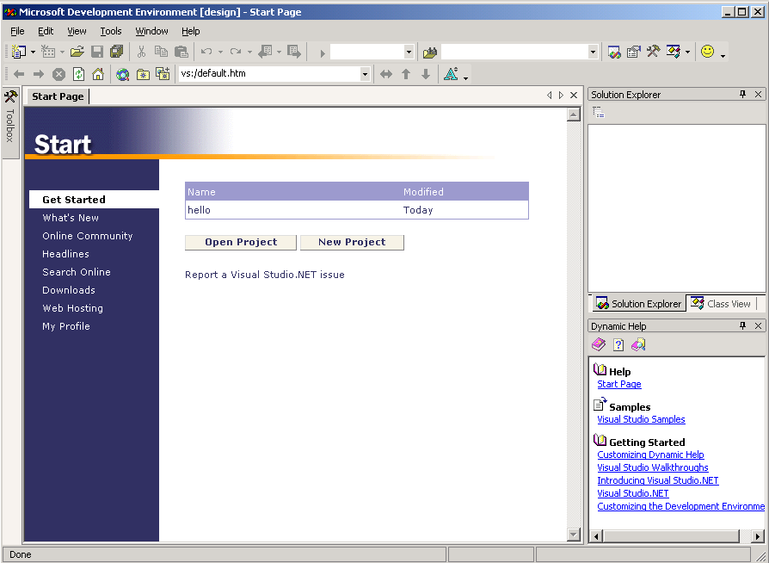

Figure 1 Start page in the Visual Studio.NET IDE

The Start page opens by default when you start the IDE this way. It provides links to the last four projects that you’ve worked on within the environment, and also provides additional resource links.

You can change all of the default settings by expanding Tools | Options and selecting your preferences.
- Select File | New | Project. The New Project window appears (Figure 2).
- In the Project Types pane, click Visual C# Projects, and in the Templates pane, choose Empty Project.
- Type “XML Comments” in the Name field, and then choose a location for your project (the default location is used in this lab). NOTE: There is a space between ‘XML’ and ‘Comments’ for the name of this project.
- Click OK.

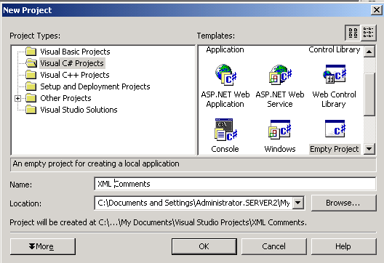

Figure 2 New Project window

Creating the XMLComment.cs Source File

The XMLComment.cs file is the source file that is used to create the XML document. XML tags and related text are commented upon within the C# code, and an XML document is created from these tags and text when the source file is compiled.

The XML comment mark is new to the C# language. Starting a line with three slashes (///) in front of text tells the compiler that any text following the slashes is an XML comment. Each line that you want to be an XML comment must begin with three slashes.

The comments must be formatted with XML tags so that an XML document can be made from them.
- Select File | Add New Item. The Add New Item window appears (Figure 3).
- In the Categories pane, click Local Project Items, and in the Templates pane, click Code File.
- Type “XMLComments.cs” in the name field. NOTE: There is NOT a space between ‘XMLComments’ for the name of this new item.

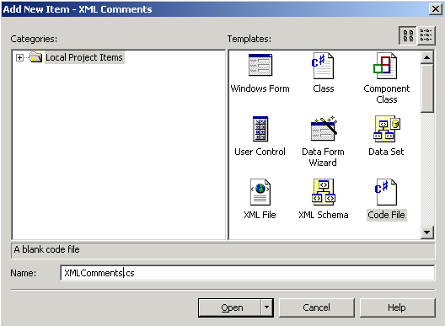

Figure 3 Add New Item window
- Click Open.
- Type the following code into the page.

using System;

class XmlElement
{
/// <summary>
/// Returns the attribute with the given name and
/// namespace</summary>
/// <param name="name">
/// The name of the attribute</param>
/// <param name="ns">
/// The namespace of the attribute, or null if
/// the attribute has no namespace</param>
/// <return>
/// The attribute value, or null if the attribute
/// does not exist</return>
/// <seealso cref="GetAttr(string,string)"/>
public string GetAttr(string name, string ns) {
return "test";
}
}
- Select File | Save XMLComments.cs, or click the save icon . The file is saved to your project folder.
- Select File | Exit. If the Microsoft Development window appears, click Yes to save changes to your project.

Opening the Project and the Source File Within the IDE
- Navigate to Start | Programs | Microsoft Visual Studio.NET 7.0 | Microsoft Visual Studio.NET 7.0.
- Select File | Open | Project.
- Expand C:\Documents and Settings\Administrator\My Documents\Visual Studio Projects\XMLComments.
- Click XMLComments.csproj or XMLComments.sln, and then click Open.

Note that clicking either file opens the project.

If the source file does not open in the main window, double-click the XMLComments.cs icon from the Solution Explorer window (Figure 4). The source file opens in the main window. Leave the IDE open to complete the following steps.

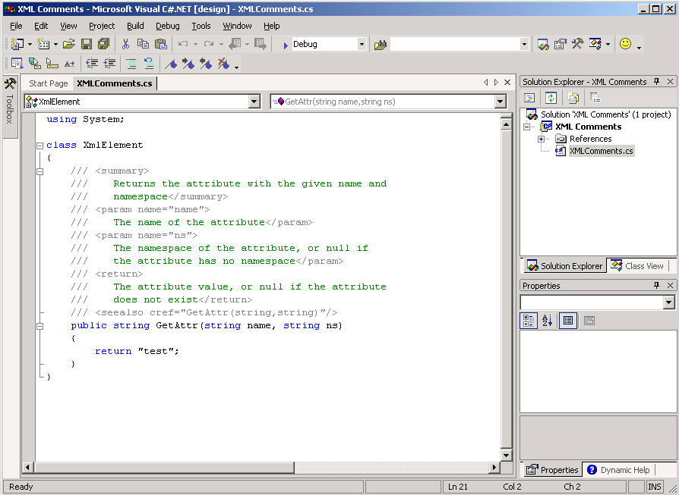

Figure 4 IDE view of XMLComments.cs document

The System namespace is declared at the top of the file. All classes within this namespace are available to the XmlElement class.

The XML elements named “param” have attributes named name and ns. These attribute values are passed to the GetAttr() method in the C# code below the comments.

Compiling the Sample

You will use two preexisting files, make.bat and doc.xsl, in this section. These files must be placed in the XMLComments project folder so that the sample will compile correctly.

The doc.xsl file provides the stylesheet template for displaying the doc.xml file in a Web browser, and the make.bat file contains C# compiler options.
- Navigate to Start | Programs | Accessories | Windows Explorer.
- Expand C:\FieldContent\Experience VS.NET\Lab2.
- Highlight the doc.xsl and make.bat files, and select Edit |Copy.
- Expand C:\Documents and Settings\Administrator\My Documents\Visual Studio Projects\XMLComments.
- Select Edit | Paste to paste the files info the XMLComments folder.

You will use the MS-DOS Command Prompt to compile the sample.
- In Windows Explorer, expand C:\FieldContent\Experience VS.NET\Lab2.
- Double-click Command Prompt.
- Type “type make.bat” and then press Enter. This displays the contents of the make.bat file on the screen.

The make.bat file contains the following parameters:
The csc command invokes the C# compiler.
The /target option specifies the format of the output file, in this case a library file, or dll (XMLComment.dll).
The /doc option tells the compiler to create an XML file (doc.xml) from the documentation comments within the source file.
XMLComment.cs is the source file used by the compiler.
- Type “make”, and then press Enter. The Command Prompt window now looks like the one in Figure 5.

The doc.xml and XMLComment.dll files are created after using the make command. They are automatically created and saved to the XMLComments project folder. This is the default for C#. You need not specify a new path unless you want to change it.

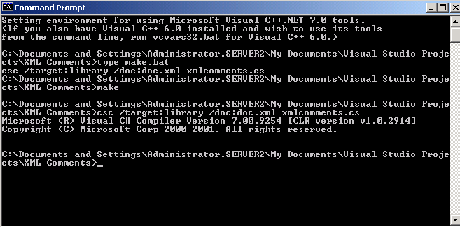

Figure 5 Command Prompt after making doc.xml
- Close the Command Prompt.

Applying the XSL Template to the XML File

You will now apply the XSL template to the XML file (doc.xml) that you created. You will open the XML and XSL files in the IDE, and then apply the XSL template so that the XML doc can be displayed correctly in a Web browser.
- In the IDE, select File | Add Existing Item.
- Expand C:\Documents and Settings\Administrator\My Documents\Visual Studio Projects\XMLComments.
- Click doc.xml, and then click Open. The doc.xml file opens in the IDE (Figure 6).

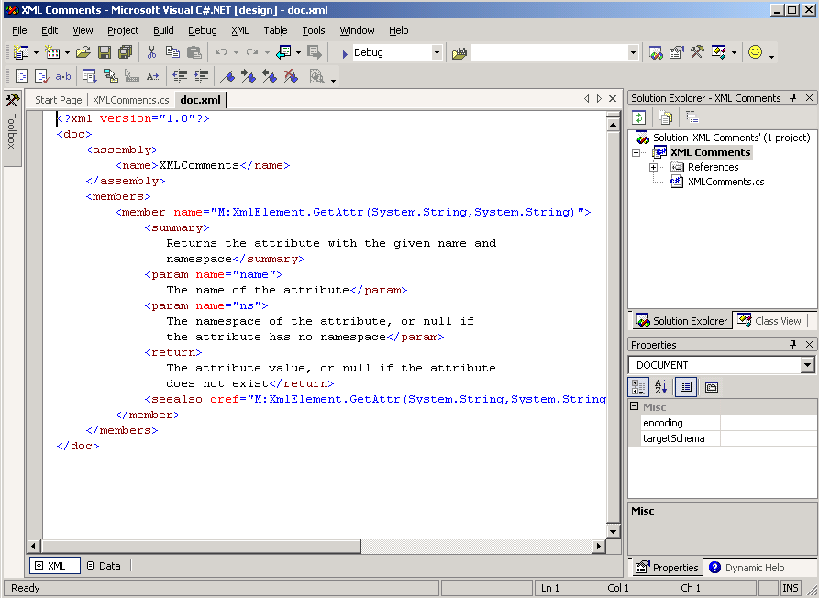

Figure 6 doc.xml in the IDE

You will now open the raw doc.xml file in the Web browser
- Select View | Open With.
- Click IEXPLORE.EXE, and then click Open. The raw doc.xml file opens in Microsoft Internet Explorer (Figure 7).

Notice that Internet Explorer displays unformatted XML files as a series of tags with collapsible “-“ signs.

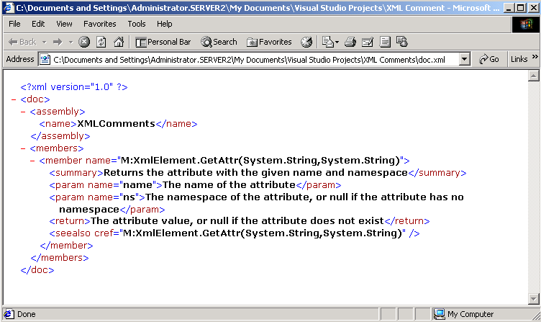

Figure 7 doc.xml in Internet Explorer Before Adding Stylesheet
- Close Internet Explorer by selecting File | Close.

Open the doc.xsl template by performing the following steps:
- In the IDE, select File | Add Existing Item.
- Expand C:\Documents and Settings\Administrator\My Documents\Visual Studio Projects\XMLComments.
- From the Files of type field, select All Files. This allows access to the doc.xsl file.
- Click doc.xsl, and then click Open. The doc.xsl template opens in the IDE (Figure 8).

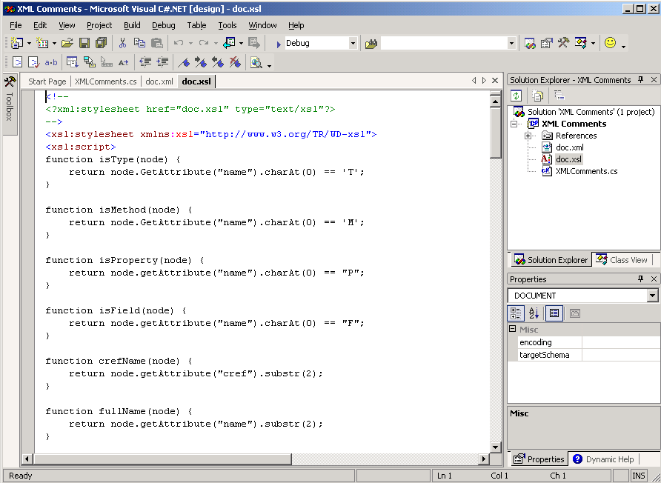

Figure 8 doc.xsl in the IDE

Notice that the doc.xsl file has a commented processing instruction on the second line, <?xml:stylesheet href=”doc.xsl” type=”text/xsl”?>. This is the line that will be added to the XML file in the next step.

Apply the doc.xsl template to the doc.xml file by performing the following steps:
- Highlight the XML processing instruction from the second line of the doc.xsl template, as shown in Figure 9, and select Edit | Copy.

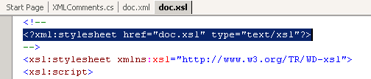

Figure 9 Stylesheet processing instruction in doc.xsl
- Click the doc.xml tab.
- Insert a blank line between the <?xml version=”1.0”?> declaration and the <doc> tag.
- Place your cursor on the blank line, and select Edit | Paste. The screen appears as shown in Figure 10.

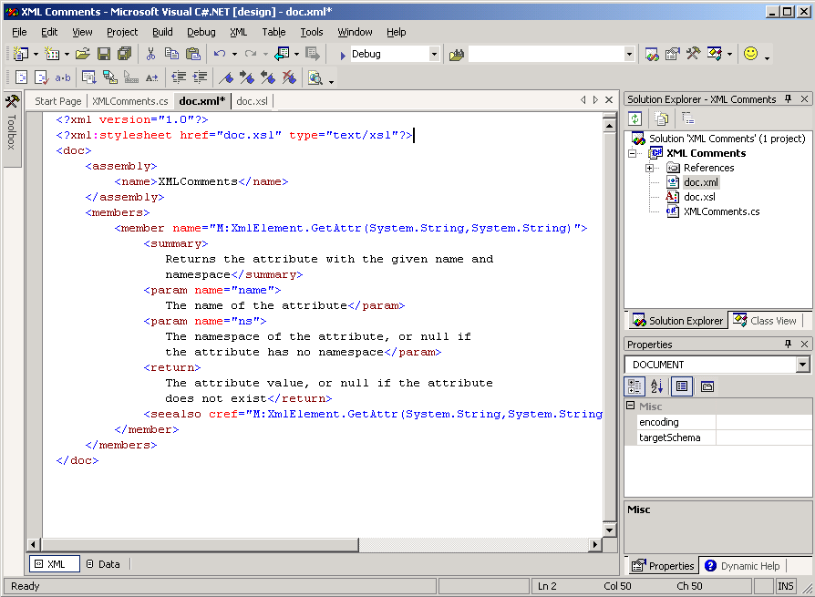

Figure 10 doc.xml with stylesheet processing instruction
- Select File | Save doc.xml.
- After you save the document, notice that the colon in the <?xml:stylesheet…?> processing instruction is removed. Place a dash (-) between the terms “xml” and “stylesheet” (without parentheses, as in the second line of Figure 11) so that this processing instruction will work correctly. After you insert the dash, select File | Save doc.xml again.

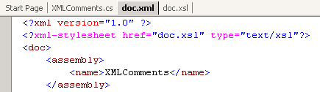

Figure 11 doc.xml with correct stylesheet formatting

Opening the Final Version of doc.xml

You can now view doc.xml in a browser with the stylesheet applied. Be sure the doc.xml tab is selected in the IDE.
- Select View | Open With.
- Click IEXPLORE.EXE, and then click Open. The doc.xml file opens in the browser with the doc.xsl formatting applied (Figure 12).

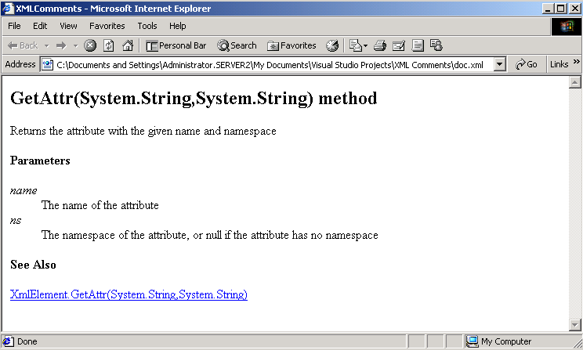

Figure 12 doc.xml in Internet Explorer with stylesheet applied

Closing Out
- Close Internet Explorer by selecting File | Close.
- Close the IDE by selecting File | Exit.

Lab 3: ASP vs. ASP.NET

In this hands-on lab, you will build both an Active Server Pages (ASP) page and an ASP.NET page, each of which generates an HTML page using data from a database. In both examples, the concept of data access is the same — they both involve a connection to the database. The difference is in the way the data are collected and displayed.

Creating the ASP Page
- Open the Visual Studio.NET Integrated Development Environment by navigating to
Start | Programs | Experience VS.NET Content | Lab 3 | ASP Source. A blank ASP page with the filename Authors.asp opens in the Visual Studio.NET IDE (Figure 1).

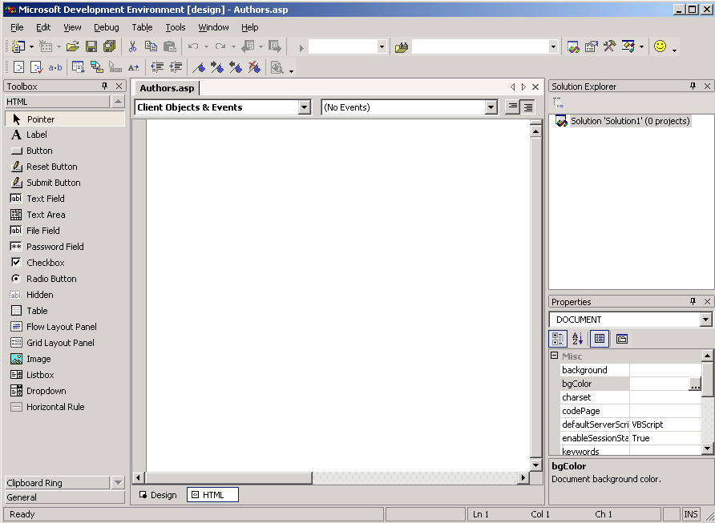

Figure 1 ASP page
- Type the following code:

<%@ Language=VBScript %>
<HTML>
<HEAD>
<META NAME="GENERATOR" Content="Microsoft Visual Studio 6.0">
<STYLE>
BODY { font:arial }
H1 { color:navy }
</STYLE>
</HEAD>
<BODY>
<DIV align=center>
<H1>Authors</H1>

<%
'
' Connecting to a database
'
dim cn
set cn = server.CreateObject("ADODB.Connection")
cn.Open "Provider=sqloledb;" _
& "Data Source=(local);" _
& "Initial Catalog=pubs;" _
& "User ID=sa"
' Retrieving Data via the Recordset Object.
dim rs
set rs = server.CreateObject("ADODB.Recordset")
rs.Open "select au_fname, au_lname, phone from authors order by au_lname",cn
%>

Notice the mix of static HTML and server-side scripting in the following code for a table. Note also the way the recordset is iterated through in order to extract the data sequentially.

<TABLE border='1'>
<TR>
<TH>First Name</TH>
<TH>Last Name</TH>
<TH>Phone</TH>
</TR>
<%
do until rs.EOF
Response.Write "<TR>"
Response.Write "<TD>" & rs("au_fname") & "</TD>"
Response.Write "<TD>" & rs("au_lname") & "</TD>"
Response.Write "<TD>" & rs("phone") & "</TD>"
Response.Write "</TR>"
rs.MoveNext
loop
%>
</TABLE>

<!-- Footer -->
<h5>Current as of <%Response.Write now%></h5>
</DIV>
</BODY>
</HTML>
- Select File | Save Authors.asp.
- Close the IDE.

Viewing the ASP page
- View the ASP page by navigating to Start | Programs | Experience VS.NET Content | Lab 3 | ASP. The screen shown in Figure 2 appears:

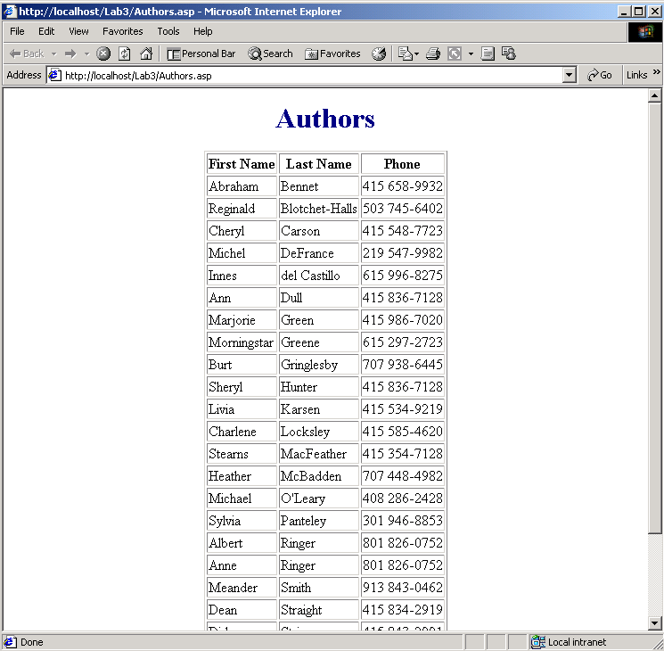

Figure 2 ASP page results

Creating the ASP.NET Page
- Open the Visual Studio.NET IDE by navigating to Start | Programs | Experience VS.NET Content | Lab3|ASP.NET VB Source. A blank ASP.NET page with the filename Authors VB.aspx opens in the Visual Studio.NET IDE (Figure 3).

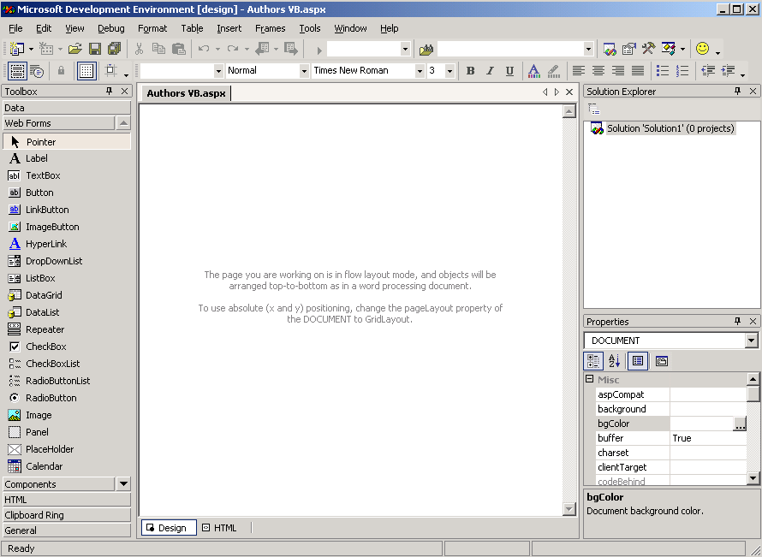

Figure 3 ASP.NET page
- Click the HTML button in the lower left corner of the Start page pane for source view.
- Type the following code:

Notice that the System.Data and System.Data.SqlClient namespaces are declared at the top of the page. All of the classes within these namespaces are available to the ASP.NET page.
<%@ Import Namespace="System.Data" %>
<%@ Import Namespace="System.Data.SqlClient" %>

<HTML>
<HEAD>
<META NAME="GENERATOR" Content="Microsoft Visual Studio 6.0">
<STYLE>
BODY { font:arial }
H1 { color:navy }
</STYLE>

</HEAD>
<BODY>
<DIV align=center>
<H1>Authors</H1>

Notice that the server-side script is completely isolated from the static HTML. You can use any run-time language, such as Microsoft Jscript® and C#, in addition to Microsoft Visual Basic®.
<script language="VB" runat="server">

Sub Page_Load(Src As Object, E As EventArgs)

Dim DS As DataSet
Dim MyConnection As SQLConnection
Dim MyCommand As SQLDataAdapter

MyConnection = New SQLConnection("server=localhost;uid=sa;pwd=;database=pubs")

MyCommand = New SQLDataAdapter("select au_fname as 'First Name', au_lname as 'Last Name', Phone from Authors", MyConnection)

The DataSet object in the following code replaces the Recordset object. Note the fill method of the SQLDataAdapter object.
DS = new DataSet()
MyCommand.Fill(ds, "Authors")

The following code sets the DataSource property of the DataGrid control. Note the Tables collection in the DataSet object. Unlike recordset objects, DataSet objects can contain more than one table.
grdAuthors.DataSource=ds.Tables("Authors").DefaultView

In the following code, the DataBind method of the DataGrid control loads the DataGrid with data. The DataGrid then displays the data as an HTML table.
grdAuthors.DataBind()
End Sub

</script>

The following line of code embeds a DataGrid object in the page. Additonal properties of the DataGrid control can also be set by adding the property/value pairs. For example: Width=”700” and BackColor=”#ccccff”.
<asp:DataGrid runat=server id=grdAuthors/>

<!-- Footer -->
<h5>Current as of <%Response.Write (Now.ToString)%></h5>
</DIV>

</BODY>
</HTML>

- Select File | Save Authors VB.aspx.
- Close the IDE.

Viewing the ASP Page
- View the ASP.NET page by navigating to Start | Programs | Experience VS.NET Content | Lab 3 | ASP.NET-VB. The screen shown in Figure 4 appears:

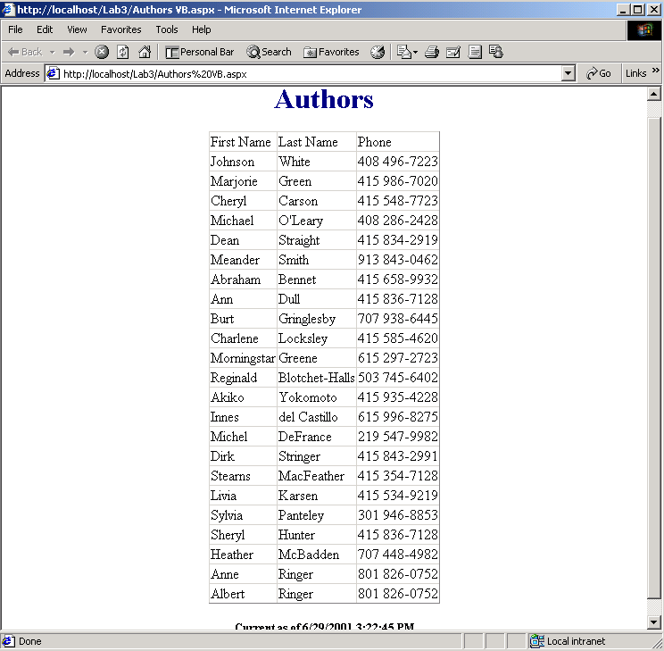

Figure 4 ASP.NET page

Closing Out

When you have finished viewing the ASP.NET page, close all the windows.

Lab 4: Server Controls Walkthrough

This hands-on lab provides an ASP.NET programming model that illustrates a few ASP.NET server controls and the C# page source. These controls behave like client-side controls, but can be run on the server. The result is that the page is buffered in memory until the event is handled and a result is processed. At this point, the entire page is sent back to the browser.

Viewing the Server Controls
- View the server controls by navigating to Start | Programs | Experience VS.NET Content | Lab 4 | Server Controls. The screen shown in Figure 1 appears.

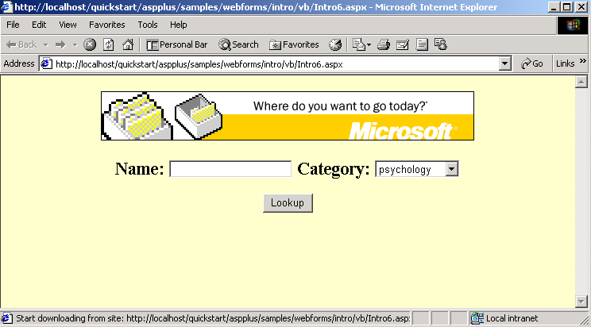

Figure 1 Server controls
- In the Name field, type your name (“Daniel” is used in Figure 2), and click Lookup.

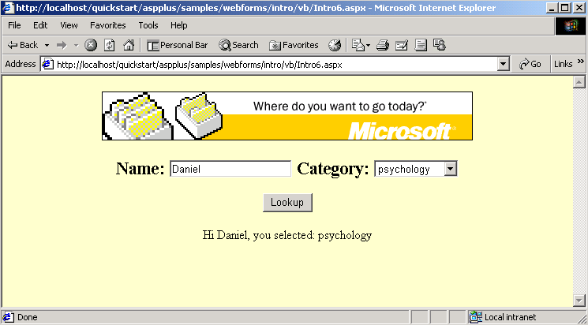

Figure 2 Lookup screen

When you click the Lookup button, the values of the Name control and the Category control are posted back to the server. This is where the values are used to generate a new page that is then sent back to the browser after processing. This is done using server-side script.

Viewing the Source
- View the source page by navigating to Start | Programs | Experience VS.NET Content | Lab 4 | Server Controls C#. The screen shown in Figure 3 appears.

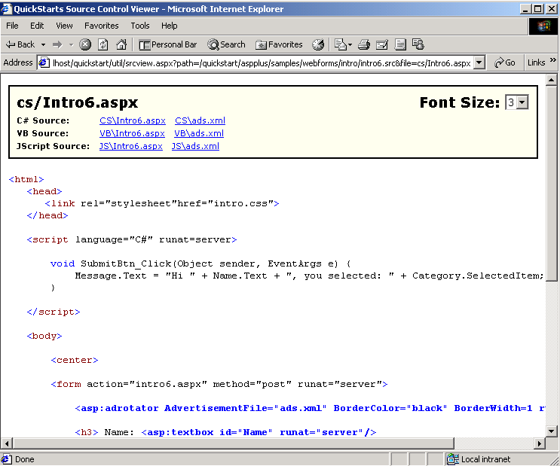

Figure 3 Server controls C# source page

On the page shown in Figure 3, you can view the C#, VB and Jscript versions of the code by clicking the links at the top of the page. Also note the way the AdRotator control accesses an XML page as its source, or AdvertisementFile. To view the code mentioned in the following examples, you may have to scroll down the page in the browser window.

In ASP.NET, you can write code to control the click event associated with buttons. In this example, the action in response to clicking the “Name” Button control was to change the value of the “Message” Label control. The event is sent back to the server, where it is processed. During the processing, the page image is buffered so that the entire page is sent back to the browser only when the script is completely processed.

Notice the way in which the properties are accessed (that is, Message.Text and Name.Text). If you are accustomed to using Visual Basic, then the use of the period operator will seem quite natural. You can access and assign properties in this way.

Another feature of ASP.NET is the availability of the server side Page_Load event, which is similar to the Form_Load event in Visual Basic. This feature allows you to program specific initializing code that sets environment variables or properties of controls in the page. For example, the text property of a button can be set to be based on data from an external data source.

Closing Out

When you have finished browsing the ASP.NET programming model, server controls, and C# source, close all the windows.

Lab 5: Using the Visual Basic Upgrade Wizard

In this hands-on lab, you will learn how to upgrade an existing Visual Basic 6.0 project to Visual Basic.NET, using the easy-to-use Upgrade Wizard.

You will first open a Visual Basic 6.0 project within the Visual Basic design environment, and then you will upgrade this project to Visual Basic.NET using the Visual Basic Upgrade Wizard and the Microsoft Visual Studio.NET Integrated Development Environment (IDE).

Opening the Visual Basic Upgrade Wizard
- Navigate to Start | Programs | Experience VS.NET | Lab5 | VB6SimpleUpgrade.vbp. The window shown in Figure 1 appears.

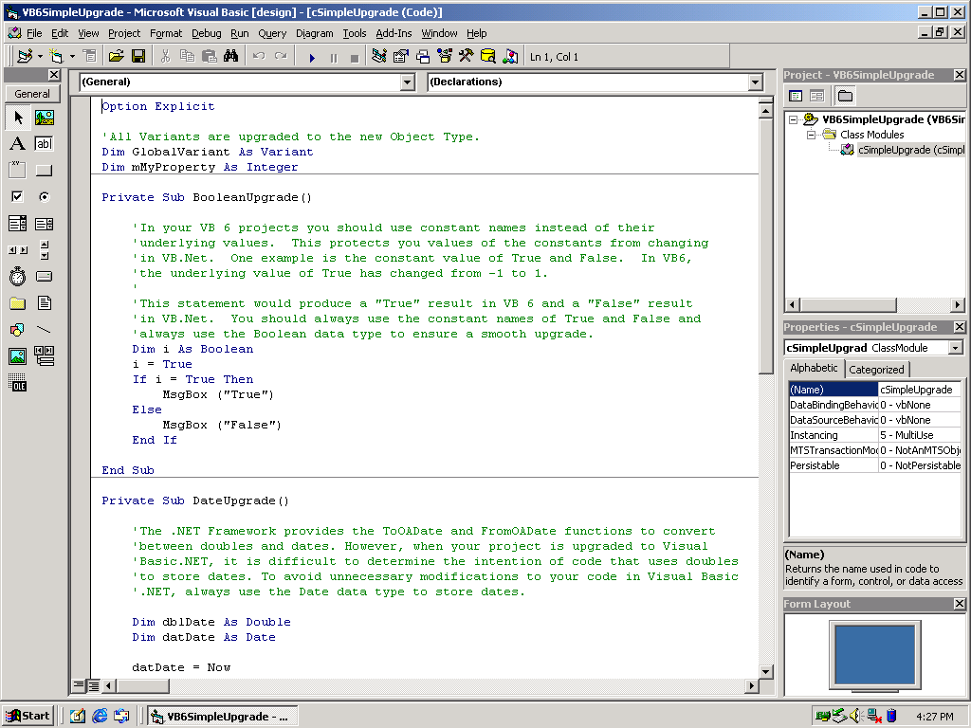

Figure 1 Visual Basic 6.0 project in the Visual Basic environment

Do not close this project, as it will be referenced later in this lab.
- Navigate to Start | Programs | Microsoft Visual Studio.NET 7.0 | Microsoft Visual Studio.NET 7.0. The Start page in the Visual Studio.NET IDE appears (Figure 2).

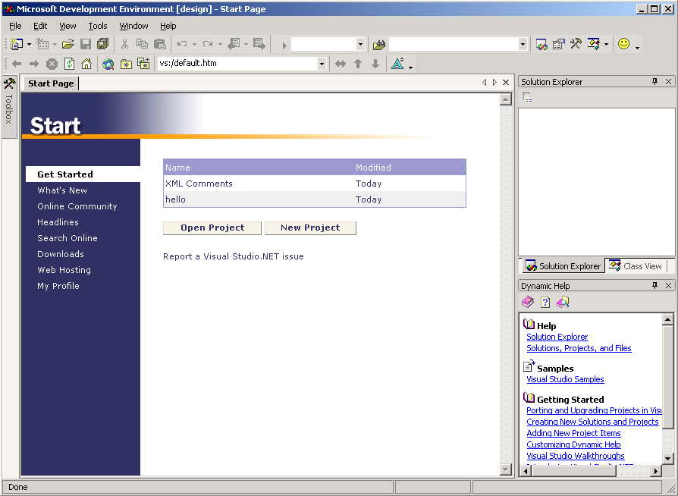

Figure 2 Start page in the Visual Studio.NET IDE

Open and upgrade the Visual Basic 6.0 project in the Visual Studio.NET IDE by performing the following step:
- Select File | Open | Project.
- Expand C:\FieldContent\Experience VS.NET\Lab5.
- Click VB6SimpleUpgrade.vbp, and click Open. Page 1 of the Visual Basic Upgrade Wizard appears (Figure 3).

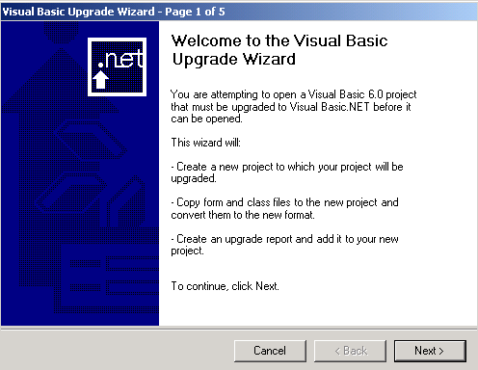

Figure 3 Visual Basic Upgrade Wizard

Using the Visual Basic Upgrade Wizard

The Visual Basic Upgrade wizard guides you through the steps required to upgrade your Visual Basic 6.0 project to Visual Basic.NET. During the upgrade, the wizard also:
- Creates a new project to which your project will be upgraded.
- Copies form and class files to the new project and converts them to the new format.
- Creates an upgrade report and adds it to your new project.

Page 1 of 5: The wizard tells you that Visual Studio.NET recognizes your current project as Visual Basic 6.0.

Click Next to continue.

Page 2 of 5: The wizard automatically detects whether your project is an executable file or a Microsoft ActiveX® DLL (the project used in this lab is an ActiveX DLL).

Leave the default setting for the additional action question.

Click Next to continue.

Page 3 of 5: You can define the location where your new Visual Basic.NET project will be created. By default, the new project will be created in a subdirectory under your current project’s path.

Leave this default setting.

Click Next to continue.

A warning box appears asking if you want to create a new folder for your project.

Click Yes to continue.

Page 4 of 5: The project is now ready to be upgraded. The time required to upgrade varies, depending on such factors as the size of your project and CPU memory.

Click Next to begin the upgrade.

Because this is a small project, the upgrade will take only a few minutes.

Page 5 of 5: This page displays the status of the upgrade and appears only while the project is upgrading.

When the upgrade is complete, the Solution Explorer window in the upper right section of the IDE screen is populated with your new project information.

One of the new files, _UpgradeReport.htm, is the upgrade report. This report gives you more details about the upgrade process and informs you whether there were any errors during the upgrade.

Viewing the Upgrade Report
- Double-click _UpgradeReport.htm in the Solution Explorer window. The report will open in the main window (Figure 4).

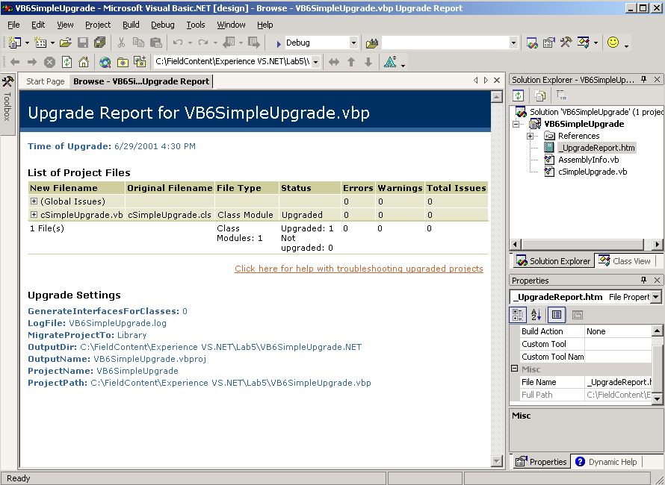

Figure 4 Upgrade Report

Now that the upgrade is complete, you can compare and contrast the code in the Visual Basic 6.0 project and the upgraded Visual Basic.NET version.
- Double-click cSimpleUpgrade.vb in the Solution Explorer Window.

The source code for the Visual Basic.NET project appears in the main window.
- Scroll to the DateUpgrade method in the code.
- Switch back to the Visual Basic 6.0 IDE, and select the DateUpgrade method from the drop-down list box.

There are similarities and differences in the code for each platform. Compare the DateUpgrade methods in each environment.

Notice that Visual Basic.NET does not store dates as doubles, while Visual Basic 6.0 does. Although the .NET Framework provides the ToOADate and FromOADate functions to convert between doubles and dates. However, when your project is upgraded to Visual Basic.NET, it is difficult to determine the intention of code that uses doubles to store dates. To avoid unnecessary modifications to your code in Visual Basic.NET, always use the Date data type to store dates.

Figures 5 and 6 show the similarities and differences between the DateUpgrade and ArrayUpgrade methods in the two environments.

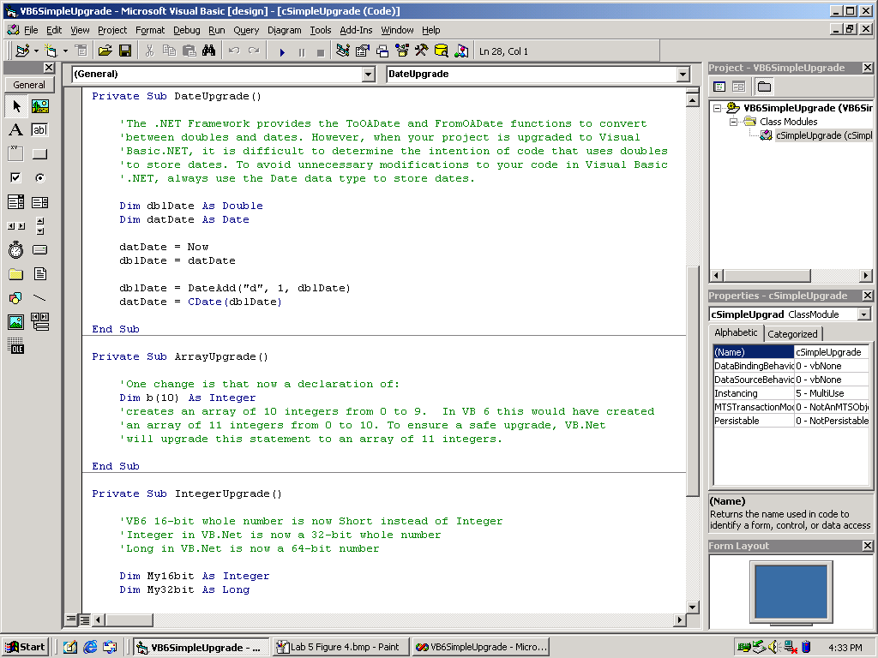

Figure 5 DateUpgrade and ArrayUpgrade methods in Visual Basic 6.0

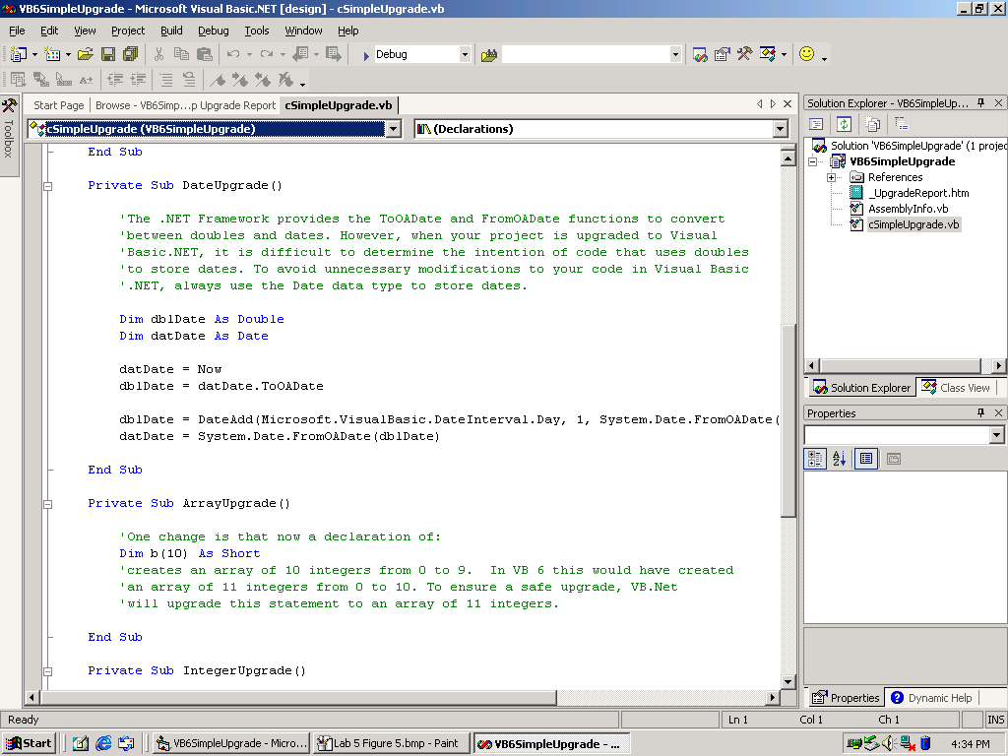

Figure 6 DateUpgrade and ArrayUpgrade methods in Visual Studio.NET
- Close Visual Basic.NET by selecting File | Exit. Click Yes when prompted to save changes to the project items.
- Close Visual Basic 6.0 by selecting File | Exit. Click Yes when prompted to save changes to the project items.

You can now view the new project files that were created during the upgrade process.

Viewing the New Project Files
- Navigate to Start | Programs | Accessories | Windows Explorer.
- Expand C:\FieldContent\Experience VS.NET\Lab5\VB6SimpleUpgrade VB.NET.

Closing Out

When you have finished viewing the project files, close all the windows.

Lab 6: Browser-Based Application

In this hands-on lab, you will build a step-by-step Hello World Web application by using a Web form.

Creating a Hello World Web Application
- Navigate to Start | Programs | Microsoft Visual Studio.NET 7.0 | Microsoft Visual Studio.NET 7.0. The Start page appears (Figure 1).

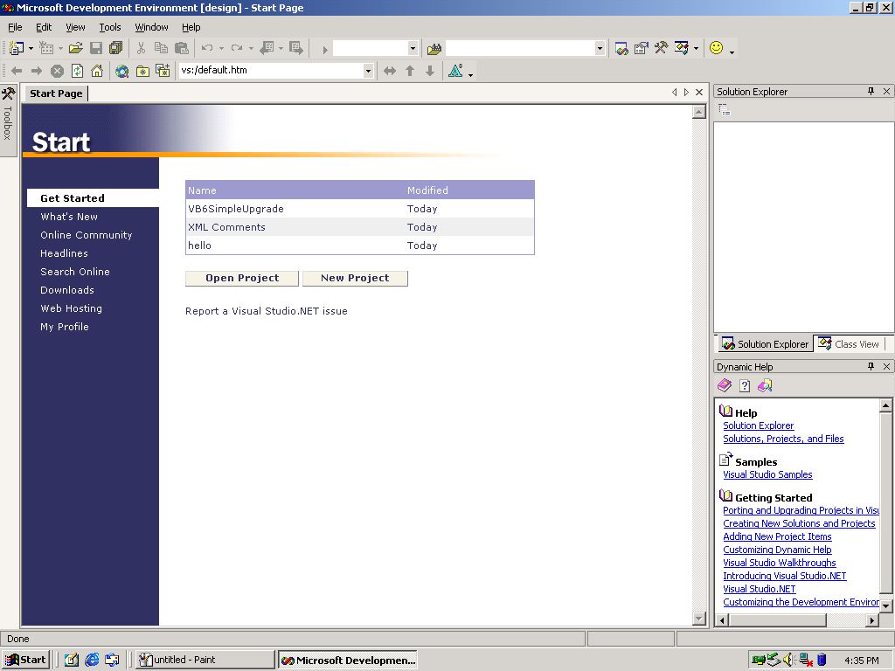

Figure 1 Start page in the Visual Studio.NET IDE
- Click the New Project button. The New Project window appears (Figure 2).

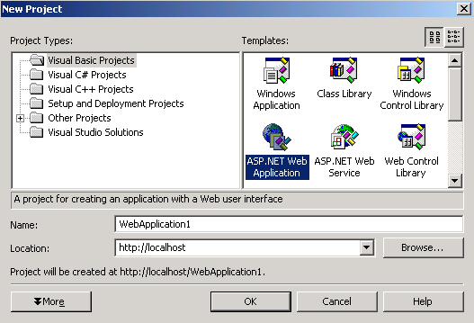

Figure 2 New Project window
- From the Project Types pane, click Visual Basic Projects, and from the Templates pane click ASP.NET Web Application. Leave the default values in the Name (WebApplication1) and Location (http://<SERVER>) fields.
- Click OK. A blank Web form design grid titled “WebForm1.aspx” appears (Figure 3).

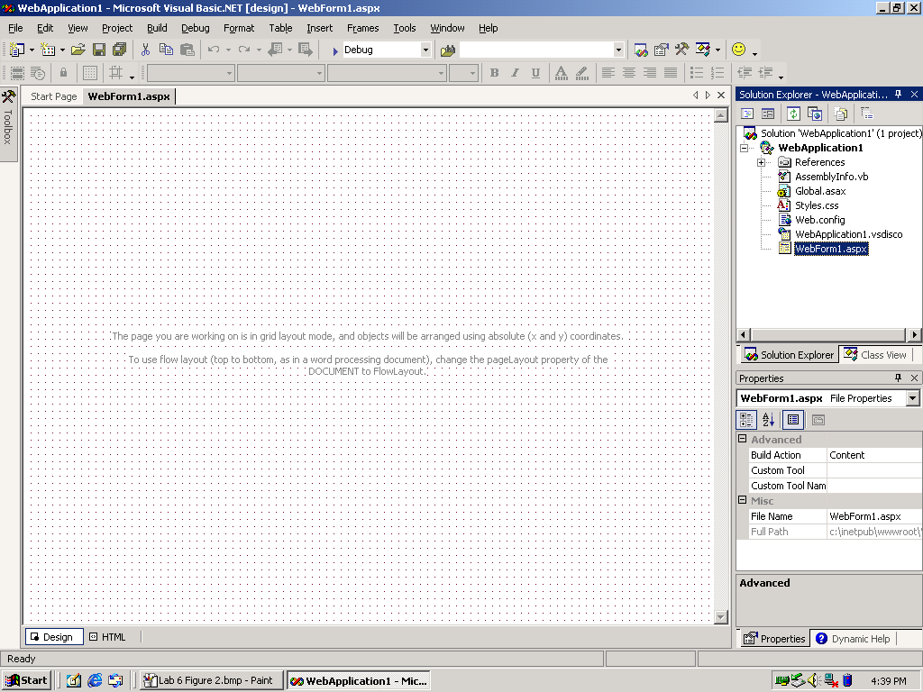

Figure 3 Blank Web form design grid

You will now use the Toolbox menu to create your Web form.

The Toolbox menu displays a list of controls available in Web forms.
- Click the Toolbox icon or select the View | Toolbox menu command.
- From the Toolbox menu, click and drag a Label to the top left of the WebForm1.aspx design grid.
- From the Toolbox menu, click and drag a TextBox to the right side of the label that you placed in step 2.
- From the Toolbox menu, click and drag a Button to the right side of the textbox that you placed in step 3.
- From the Toolbox menu, click and drag another TextBox and place it under the first textbox that you placed in step 3. Your Web form is now similar to the one shown in Figure 4.

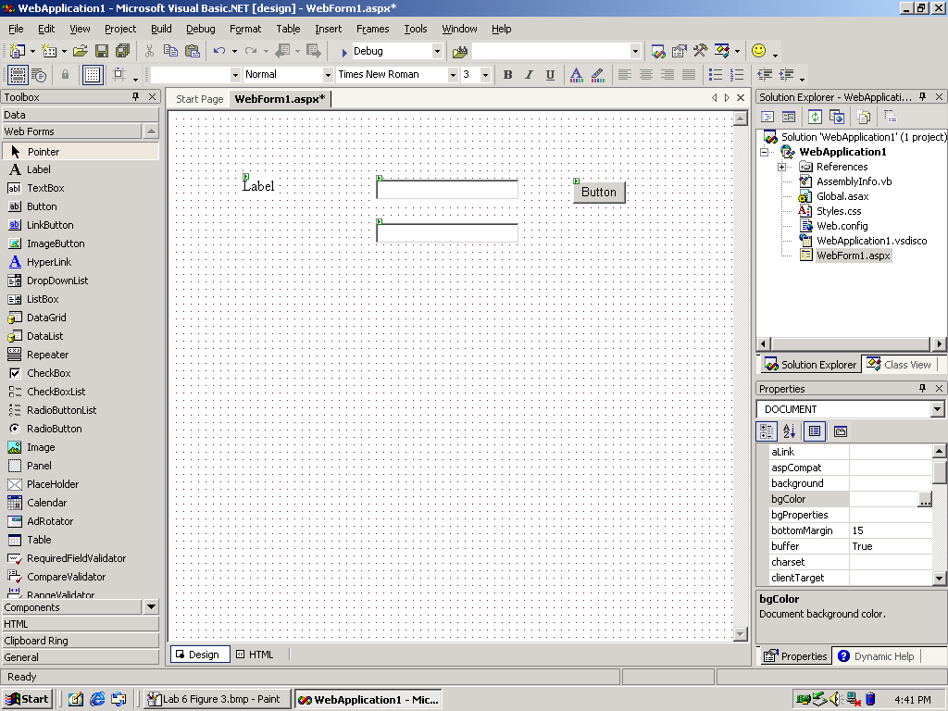

Figure 4 Web Form design grid with objects

Editing a Web Form

You will now edit the objects that you dragged to your form (WebForm1.aspx). You will use the Properties box on the lower right corner of the page to edit the properties of the label and the button. You will also add a procedure to the button.
- On the form, click Label.
- From the Properties box, change the Text field from “Label” to “Enter Name:”.
- On the form, click Button.
- From the Properties box, change the Text field from “Button” to “OK”.
- On the form, double-click newly created button titled OK. The source code for WebForm1.aspx.vb appears with two procedures – Page_Init and Button1_Click. In this lab, you will modify only the Button1_Click procedure.

Caution: Do not edit the Page_Init procedure, as it is used by the Web Form Designer.
- Enter the following code under the Button1_Click procedure:

If TextBox1().Text <> “” Then
TextBox2().Text = “Hello “ & TextBox1().Text & “!”
End If

When this code has been entered, the application is ready to run.

Note that because this is a Beta 2 release of Visual Studio.NET, the application may take a bit longer to load than expected. This is because there is a lot of debugging code to go through.
- Press F5.

After a moment, the application compiles and is loaded into a new browser window (Figure 5).

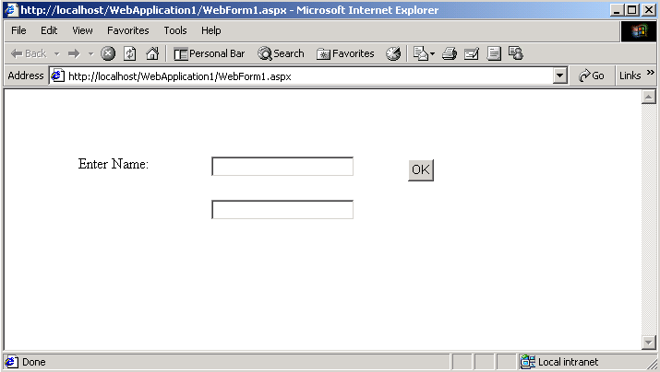

Figure 5 Browser view of the Web form
- In the top text box, enter a name such as “John”.
- Click OK. Your edited Web form appears as shown in Figure 6.

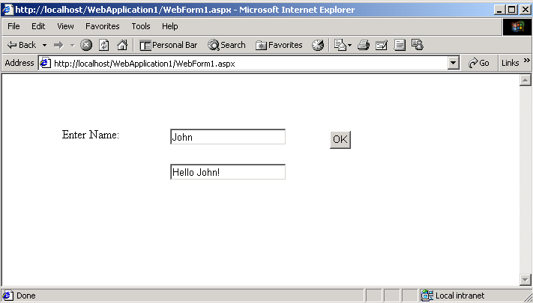

Figure 6 Web form results

Closing Out

Follow these steps to close the application.
- Close Internet Explorer by selecting File | Close.
- Close the IDE by selecting File | Exit.

Lab 7: Inheritance and Override

In this hands-on lab, you will build a simple application that demonstrates the concept of object inheritance.

Visual Basic.NET supports inheritance by allowing you to define classes that serve as base classes for other derived classes. The derived classes inherit, and can extend, the properties, methods, events, and data members of the base class. Derived classes can also override inherited methods with new implementations of base methods. All classes are inheritable by default. Forms, which are in fact classes, can also use inheritance to define new forms based on existing forms.

Inheritance Statements and Modifiers

Visual Basic.NET introduces several statements and modifiers to support inheritance. The following table describes them:
Statement/Modifier | Description
Inherits | Inherits statement — Specifies the class (also known as the base class) from which the current class inherits. The Inherits keyword is only allowed in classes and interfaces.
NotInheritable | NotInheritable modifier — Prevents programmers from using the class as a base class.
MustInherit | MustInherit modifier — Specifies that instances of the given class cannot be created. The only way to use the class is to inherit from it.
Overridable | Overridable modifier — Allows a property or a method to be overridden in an inheriting class. Public methods are NotOverridable by default.
Overrides | Overrides modifier — Allows you to override a property or method that is defined in the base class.
NotOverridable | NotOverridable modifier (default) — Prevents a property or method from being overridden in an inheriting class.
MustOverride | MustOverride modifier — Requires the inheriting class to override the property or method. When the MustOverride keyword is used, the method definition consists of just the Sub, Function, or Property statement. No other statements are allowed and, more specifically, there is no End Sub, End Function, or End Property statement. Classes with MustOverride methods must be declared as MustInherit. Public methods are NotOverridable by default.
Shadows | Shadows modifier — Allows reuse of the names of inherited class members. Shadowing a name does not remove the inherited type members by that name; it only makes all of the inherited type members, including overloaded and overridden members, unavailable in the derived class. Shadowing re-declares the class member in the derived class.

Certain combinations of these statements and modifiers cannot be allowed:
Overridable and NotOverridable are mutually exclusive and cannot be combined.
NotOverridable cannot be combined with Overridable or MustOverride.
Overrides implies Overridable and cannot be combined with MustOverride.
MustOverride implies Overridable and cannot be combined with NotOverridable.
MustOverride methods cannot override other methods, and so cannot be combined with the Overrides modifier.

Inheritance Example 1

You will create a simple executable application using the Microsoft Visual Studio.NET Integrated Development Environment (IDE).
- Open the IDE by navigating to Start | Programs | Microsoft Visual Studio.NET 7.0 | Microsoft Visual Studio.NET 7.0. The Start page appears.
- Create a new project by clicking the New Project link. The New Project window appears.
- In the Project Types field, click Visual Basic Projects.
- In the Templates field, click Empty Project.
- Click OK.

Add a class to the project by performing the following steps:
- On the Project menu, click Add Class
- In the Name field type “A.vb”.
- Click Open. An empty class appears (Figure 1).

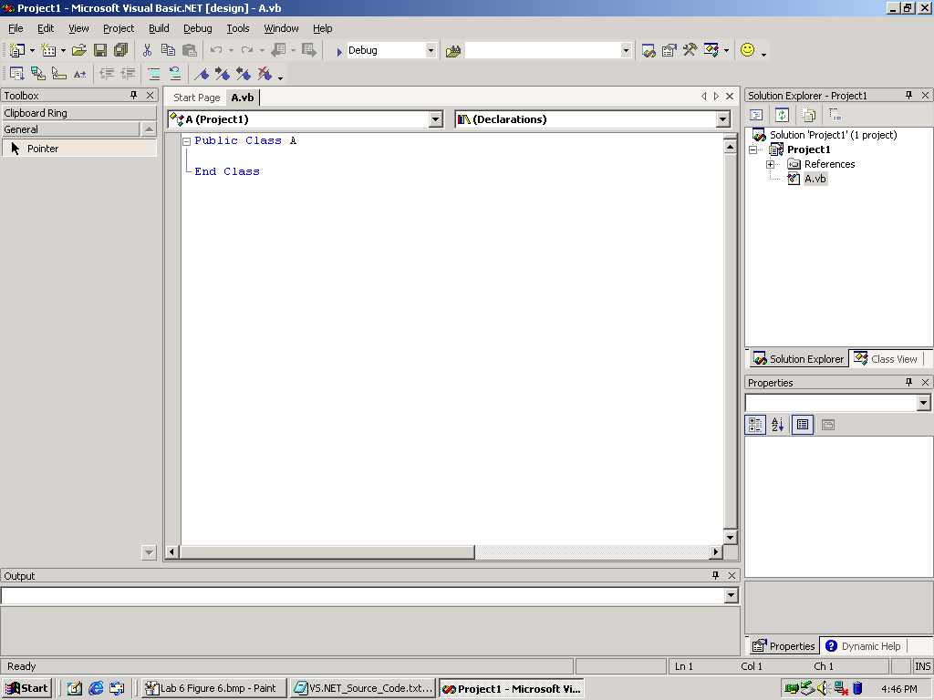

Figure 1 Empty class
- Enter the following code above Public Class A:

Imports System
Imports System.Console

- Add the following code to complete Class A:

Class A
Public Sub F()
Console.WriteLine("A.F")
End Sub

Public Overridable Sub G()
Console.WriteLine("A.G")
End Sub
End Class

- Add the following code beneath Class A:

Class B
Inherits A
Public Shadows Sub F()
Console.WriteLine("B.F")
End Sub

Public Overrides Sub G()
Console.WriteLine("B.G")
End Sub
End Class

In the following portion of the code, you declare two objects and invoke both of their methods to see the results.
Class Test
Shared Sub Main()
Dim b As New B()
Dim a As A = b
a.F()
b.F()
a.G()
b.G()
End Sub
End Class

- Press F5 to run the application. The Output window appears with the results
(Figure 2).

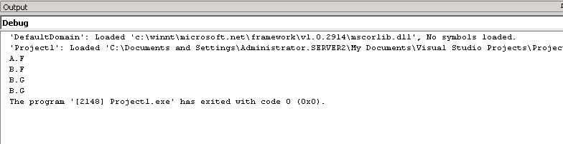

Figure 2 Inheritance example 1 output results

The results for b.F() and b.G() are to be expected. Notice, however, that the statement a.G() invokes B.G, not A.G. This occurs because we have allowed method G of class A to be overridden. The actual method implementation is determined at run time by method G of class B, which overrides the method inherited from class A. This ability to change the compile time method implementation is what makes inheritance such a powerful feature in object-oriented programming.
- Select File | Close Solution.
- Leave the IDE open for the next example.

Inheritance Example 2

This example further demonstrates inheritance.
- Select File | New | Project. The New Project window appears.
- In the Project Types field, click Visual Basic Projects, and in the Templates field, click Empty Project.
- Click OK.

Now add a class to the project by performing the following steps:
- On the Project menu click Add Class.
- In the Name field, type “A.vb”.
- Click Open. An empty Class appears.
- Enter the following code Above Public Class A:

Imports System
Imports System.Console

- Add the following code to complete class A:

Class A
Public Overridable Sub F()
Console.WriteLine("A.F")
End Sub
End Class

- Add the following code beneath Class A:

Class B
Inherits A
Public Overrides Sub F()
Console.WriteLine("B.F")
End Sub
End Class

Class C
Inherits B
Public Shadows Overridable Sub F()
Console.WriteLine("C.F")
End Sub
End Class

Class D
Inherits C
Public Overrides Sub F()
Console.WriteLine("D.F")
End Sub
End Class

In the following portion of the code, you declare four objects and invoke their methods to see the results.
Class Test
Shared Sub Main()
Dim d As New D()
Dim a As A = d
Dim b As B = d
Dim c As C = d
a.F()
b.F()
c.F()
d.F()
End Sub
End Class

- Press F5 to run the application. The Output window appears with the following results (Figure 3).

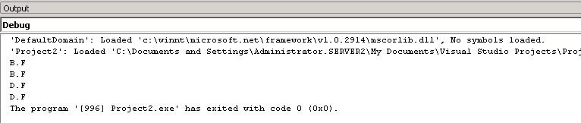

Figure 3 Inheritance example 2 output results

In class A there is an overridable method. In class B there is an override method. Class A and class B are quite similar to the previous example. Class B inherits class A and overrides method F, thus changing the run-time implementation of method F. Both a.F() and b.F() invoke B.F, because method F of class A has been overridden by override method F of class B.

In class C, we have another overridable method, which is also a shadow method. This means that it will shadow the compile-time implementation of the inherited method F, or it can be overridden if another class inherits it. Class D inherits class C. In class D there is an override method that changes the run-time implementation of class C method F. It is because of this that both c.F() and d.F() invoke D.F.

Because methods are allowed to shadow inherited methods, it is possible for a class to contain several overridable methods with the same signature. However, this does not result in ambiguity, because all but the most derived method is hidden and therefore inaccessible, and there is consequently no naming conflict.

It is possible to invoke the shadowed overridable method by accessing an instance of D through a less derived type in which the method is not hidden.

Closing Out

When you have finished viewing the project files, close all the windows.

Reset Instructions

Your computer can be cleared of all lab-related information by using the HOLT1-01 Experience Visual Studio.NET.msi installer package and the Reset.vbs script file.

Follow the steps below to reset your computer.
- Double-click HOLT1-01 Experience Visual Studio.NET.msi. The InstallShield Wizard will appear.
- Click Next. A page titled Program Maintenance appears.
- Select Remove, and then click Next. A window titled Remove the Program appears.
- Click Remove. This will remove all lab-related files and folders.
- Click Finish.

You will now remove the shortcuts from the Start menu.
- Double-click Reset.vbs. Click OK when the Windows Script Host window appears.

To run through the labs again:
- Install HOLT1-01 Experience Visual Studio.NET.MSI.
- Execute Setup.vbs.

Additional Resources

MSDN events online: http://msdn.microsoft.com/training/seminars/quarterlyevent.asp

TechNet events online: http://www.microsoft.com/technet/events

MSDN web: http://msdn.microsoft.com

Visual Studio.NET online: http://msdn.microsoft.com/vstudio/nextgen

